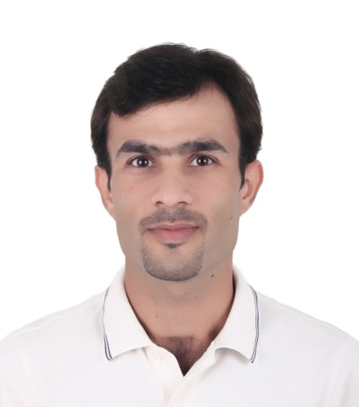
c.v.

Personal Details:
Name : Nibras Najm Abbood
Date of birth : 29.09.1984
Nationality : Iraqi
Gender : Male
Marital : Single
Mobile : 009647806656617
E-mail :nibrasnajm1984@yahoo.com

Education:

-B.Sc in Department of Fish and Marine Resources, college of Agriculture
(Basrah Uni.) 2004 - 2007.
-(Biochemistry , Aquatic ecology , experimental design , fish classification , fish feed and feeding , animal physiology , Aquatic organisms physiology , Invertebrate , Limnology , fish biology , Agric. Extension , genetics.
Fish diseases and parasites , fish marketing , ornamental fish , oceanography , plankton , aquatic plants , seminar & projects , microscopic preparation , fisheries management , fish technology , aquatic environmental pollution , fish culture , marine biology.
General Botany, general chemistry , computer science , Ichthyology , mathematics , Geographical distribution , commercial fisheries , Zoology , physics , English language , practical ecology , engineering drawing .
Basis of Microbiology , general ecology , organic chemistry , field training , basis of Soil , agric. Machinery , basis of Insects , basis of Horticulture , basis of animal production , statistic .

-MSc in genetic Engineering, (Huazhong University of science and technology), China (Tentative date of completion: June 2012).
- (Molecular genetics , genetics , proceeding of proteins research , proceeding of molecular biology , proceeding of genetics , Ecotoxicology , Advance Ecology , Emmunology , Zebrafish toxicity , proceeding of cardiovascular research).

-Course in English language department of live languages in Basrah University.
-Course in Computer Programming.
-Member of the World Peace organization, Iraq, Basrah.

Work Experience:

- Work in the museum of department of fisheries and marine resource / college of agriculture/Basra University/Iraq2007-2010.
- Work as a researcher at college of agriculture 2008-2010.

HUST Experience (2010- 2012):

- Gene cloning, Microinjection, Design primers, O staining, Western blot, and InSitu Hybridization technique.

Publications:

- Comparative and Evolutionary Analysis of the HES/HEY Gene Family Reveal Exon/Intron Loss and Teleost Specific Duplication Events. PlosOne, 2012.
- MiR-142-3p regulates Cardiovascular System during zebrafish development. Cell Biology, 2014.
- MiR-145 regulates hematopoiesis during zebrafish development. Cell Biology, 2014.

Other Experience:

- Work as a coordinator in the World Peace organization.
- Work as interpreter in the in CPNC Managers Training Institute, Beijing (中国石油工程建设集团公司业主社区 ) for a month.

Languages:

Arabic native
English good
Chinese: HSK level 3 and level 4.

